Day-06

1. Install nginx and run nginx on port number 81.

Using the command of: yum nginx and after that gave human confirmation with yes,

Either we will do like this also this for no human action mandatory

Yum install nginx -y

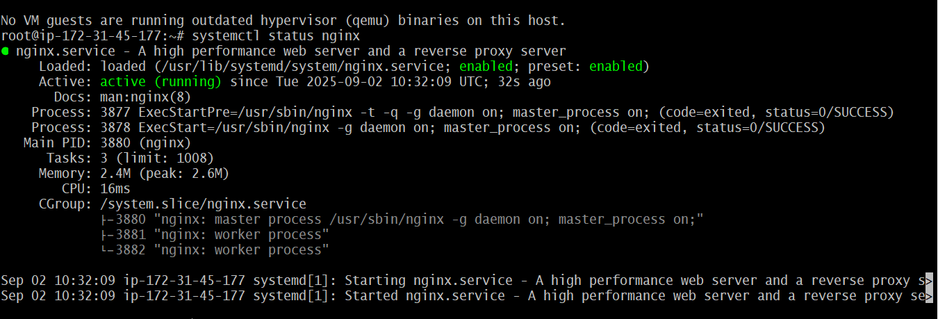

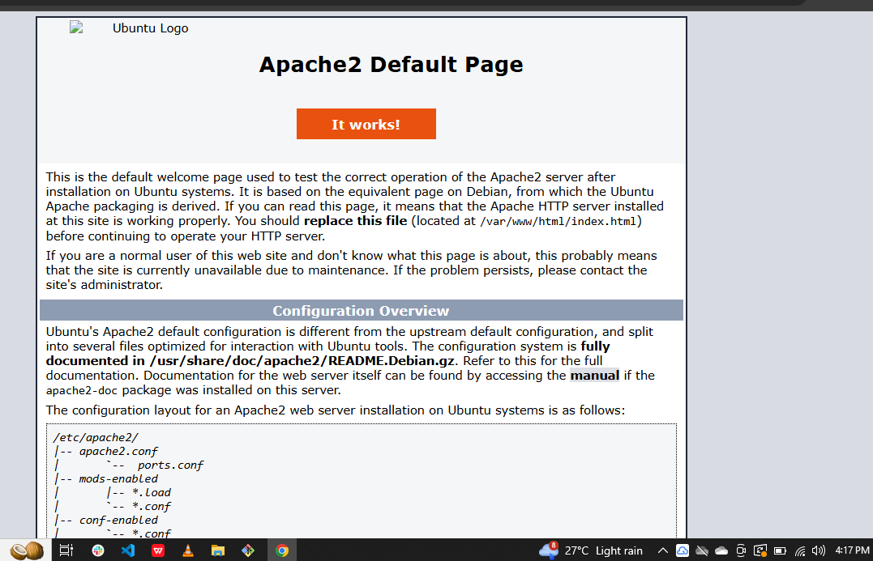

For port num 81 chnged succesfully with the command of

vi /etc/nginx/nginx.conf

1. Deploy a sample index.html file on nginx.



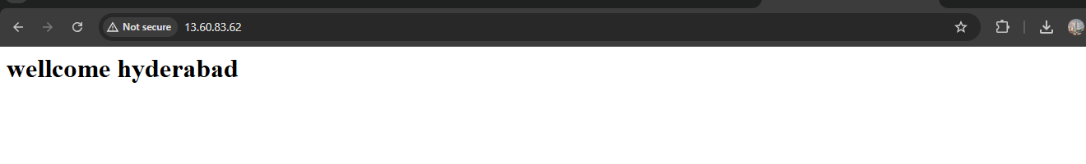

1. Install Apache and run Apache on port number 82

For install apache am using of httpd nd it will installed successfully,

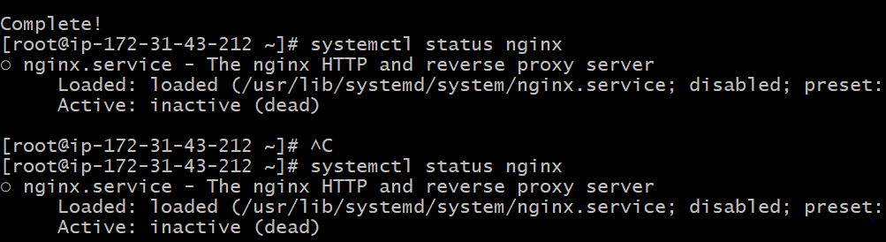

1. Deploy a sample index.html file on Apache.

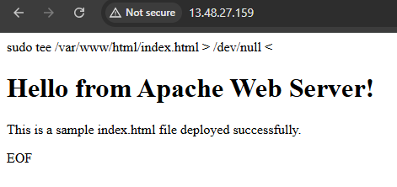

1. Install Apache tomcat on port number 8082

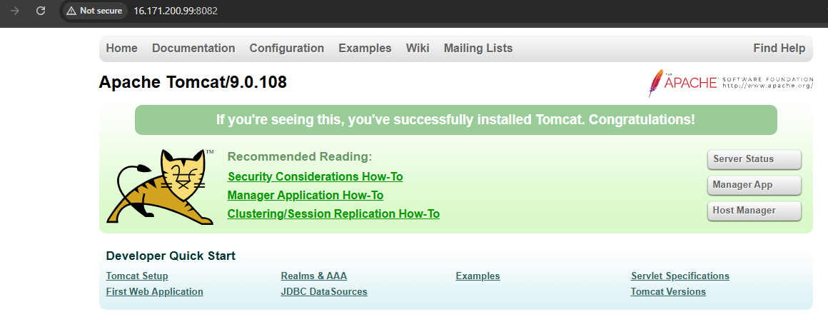

1. Deploy a sample app on webapps
2. Create a tomcat.service file for tomcat.

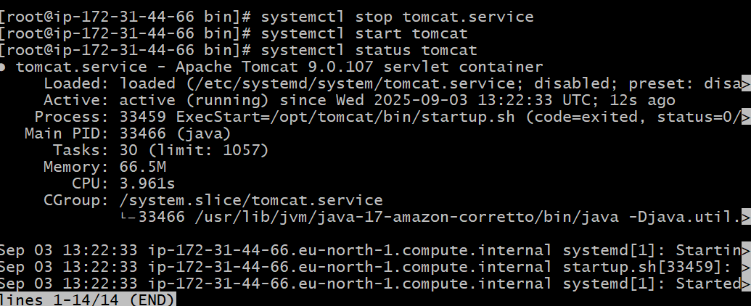

1. Configure HA Proxy server